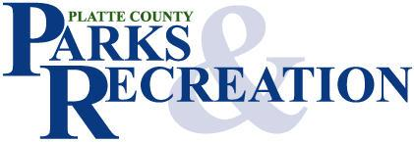

Parks and Recreation Partnership Grant

Guidelines & Application

I. Program Overview
Introduction
B. Administration & Funding
Eligibility & Requirements
Evaluation Criteria
Process

Application
Directions
B. Application Form
C. Budget Form

___________________________________________________________________________________
415 Third Street Platte City, MO 64079 (816) 858-3419
I. Program Overview

A. Introduction

Recognizing that Platte County is a growing and dynamic area with a population that demands the highest quality parks and recreation opportunities, the Platte County Commission has created the Parks and Recreation Partnership Grant Program to address unique recreational needs and demographics with the communities of Platte County. This program is intended to promote the development of local parks and recreation facilities within the selected Platte County communities to enhance the quality of life for all residents.

The absolute priority of the Parks and Recreation Partnership Grant program is to significantly increase recreational opportunities for Platte County residents. All funds committed under this program shall be for the sole use of expanding and enhancing parks and recreation facilities. Funds may not be utilized for programs or facilities that are not directly related to public recreation.

B. Administration & Funding

Under the direction of the County Commission, the program is administered by the staff of the Parks and Recreation Department and Board of Park Commissioners. All applications for funding are submitted to the Department and reviewed for recommendation to the County Commission. Staff of the Parks and Recreation Department will be available to assist community leaders to develop their projects to meet the highest local and regional needs.

Available funds for the program are derived from the 1/4 cent sales tax approved by Platte County voters in August, 2020. It is estimated that approximately $8,000.000 will be available over next decade for this partnership program. Partnership grant awards will range between $50,000 to $1,000,000 per project. This program is intended to be an opportunity for communities to partner with the County to improve local parks and recreational facilities.

C. Eligibility & Requirements

Project sponsors for the program must be a local government or political subdivision of the state of Missouri. All projects must take place within Platte County.

The Project sponsor must commit to the following:
- Project design
- Construction management
- Operations, and maintenance including capital maintenance
- Public access

Platte County does not contribute to organizations that practice discrimination by race, color, creed, sex, age or national origin. Projects will be funded only for projects which primarily and significantly benefit Platte County citizens.

Sponsors are required to provide a complete project application, administer the project through completion, and operate and maintain the site(s) after completion.

Eligible projects include, but are not necessarily limited to, the development or improvement of recreational facilities such as playgrounds, ballfields, and trails. Grant funds may also be used to acquire property for the purpose of park and recreational facility development. The County is unable to fund projects through the program that do not substantially improve recreational opportunities for county residents. Projects not eligible for funding include, but are not necessarily limited to, maintenance activities, administrative or travel expenses, fundraising events, or any project that requires the use of eminent domain or condemnation. The following requirements shall be made of each awarded partnership grant:

1. All development and renovation projects for parks and recreation facilities shall comply with all applicable local, state and national laws including the Americans with Disabilities Act. All equipment purchased, installed, and/or renovated shall be in accordance with U.S. Consumer Product Safety Commission (CPSC) and American Society of Testing Materials (ASTM) guidelines and be available for public use during its standard expected lifetime.

2. Projects involving land acquisition must include ownership by the County or local government and be dedicated for public recreational purposes in perpetuity.

3. Recreation programs intended to take place at facilities developed through this program must be open to the general public.

4. Project sponsors shall agree to include reference to Platte County on project signage and/or promotional literature produced by the sponsor and to accept any additional identification signage from the County to be placed at the project site.

D. Evaluation Criteria

This is non-competitive grant program. Local, unique priorities should be developed and addressed based on citizen input from each community receiving Partnership Grant funds. County officials and staff are available as needed to assist each community in developing plans for use of the funds.

- Considerations for Projects:
- Does the project address a major need in the community?
- Is the project supported in the local government's long-range plan and/or the Platte County Parks System Master Plan?
- Is the implementation of the project feasible? Can it be done in the time allotted?
- Are the quality of the components and features of the project high?
- Are there matching funds or non-cash donations for the requested grant?
- Can the project be adequately maintained by the sponsor after completion?
- Will the project have a positive impact on aesthetics and the environment?
- Does the project use “green technology” and use recycled materials or energy conservation measures?
- Important Public Input & Partnerships
- The proposed project must be approved by the governing body of the local government
- Has the general public been a part of project planning?
- Are partnerships available to develop and maintain the project?
- Are partners contributing matching resources to the project?
- Project Budget and Finances
- Are the proposed budget estimates qualified and reasonable?

E. Process

All proposals must be received by 5:00 p.m., September 4th, 2026, in order to be considered. Please contact the Parks and Recreation Department if you should have any questions regarding the application or project eligibility before this deadline.

All costs associated with the project must be documented. Any costs incurred prior to the formal approval of the project are ineligible for matching purposes or reimbursement. All grant funds are provided on a reimbursement or progress payment basis. Approved project sponsors shall follow the following process for reimbursement/ invoice payment:

- Approve formal contract or project agreement with County
- Complete project planning and/or construction documents
- Purchase equipment and/or contract for services
- Complete the project or program and notify the County in writing that all requirements of the grant agreement have been satisfied, including CPSC and ASTM guidelines
- Submit paid invoices and documentation of payment for project expenses up to the amount approved or request progress payments for work completed

The County will examine submitted materials and inspect the project for compliance with the grant agreement. Upon satisfactory completion, the County will issue a check in approximately 15 business days to the project sponsor for an amount up to the approved award or progress payment amount.

II. Application

A. Directions

- Submit only one application form for the entire community Partnership Grant project.
- Application must be in original format and typewritten. No handwritten applications will be accepted.
- Project description section must be completed.
- Application must be signed and dated.
- ALL new construction or renovation projects are required to include a Development Plan or a Diagram with the application.
- Local governments shall include a letter from their Board of Alderman supporting the application and committing any matching funds or resources.
- If partnering with a local athletic association or other organization, include a letter of support from their governing body committing them to their portion of the project
- Please pay particular attention to the "Itemized Budget" page of the application. Directions for completing this page are written above the Itemized Budget Table. Round all amounts to the nearest dollar and use specific line item costs.
10) Make one copy of your Application for the County.
11) Deliver the original and one copy to:
Platte County Parks and Recreation Department
415 Third Street
Platte City, Missouri 64079

Application submissions MAY also include the following optional support information: map identifying the project location; photographs of proposed project site; promotional printed fliers or brochures for your project.

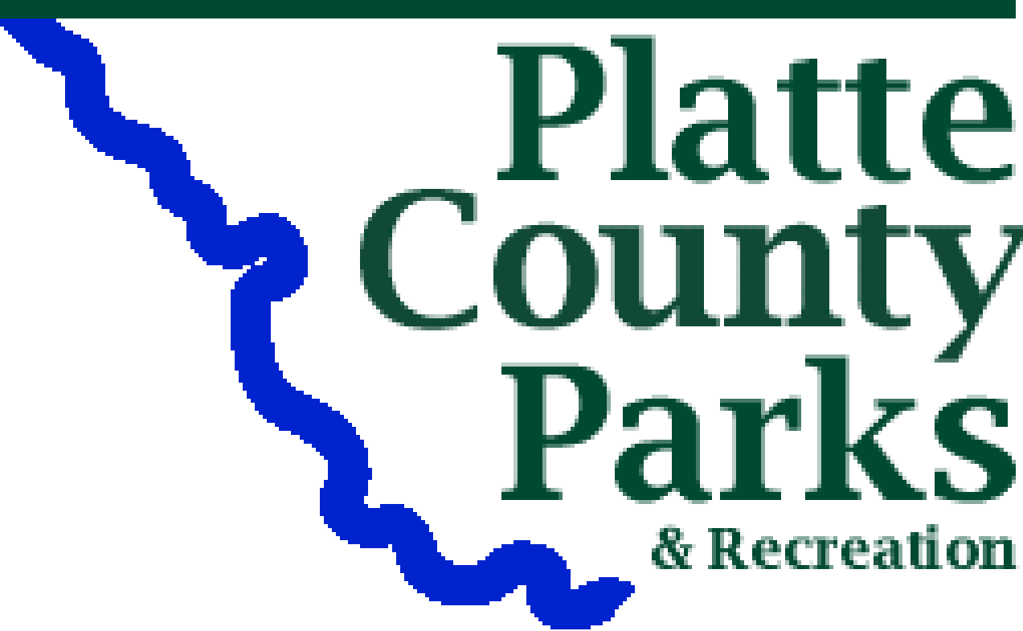
Parks and Recreation Partnership Grant
APPLICATION

1. __________________________________________________________________________
Name of Applicant Agency or Organization

2. __________________________________________________________________________
Mailing Address City State Zip

3. __________________________________________________________________________
Primary Contact Person Title Phone

4. NAME OF PROJECT: ________________________________________________________

5. LOCATION OF PROJECT(s):

__________________________________________________________________________
Street Address/Intersection

- Who owns the lands upon which the project will take place?:

__________________________________________________________________________

- TYPE OF PROJECT(s): Check all that Apply

New Development Renovation/Improvement Land Acquisition Capital Maint.

8. POPULATION SERVED: Annual expected number of users or visitors:__________________

Target demographic/age group:_________________________________________________

9. SIGNATURE OF RESPONSIBLE AGENT
“I hereby certify that the information contained in this application is true and correct to the best of my knowledge. I understand that this application will be evaluated on the basis of the information submitted and that the submission of incorrect data can result in this application being withdrawn from consideration for funding. If the organization I represent is awarded a grant, we hereby agree to use the funds for the purposes stated and abide by all terms and conditions.”

____________________________________________________ _________________
Signature Date

___________________________________ ___________________________________
Printed Name Organization

Parks and Recreation Partnership Grant
Project Description

Using the space provided, describe the essential components of your project. Describe the need for the project, the increased recreational value it will provide, and why County funds are needed.

1. PROJECT IDENTIFICATION: Describe the basic elements of your proposed project. Include a
statement identifying the needs to be addressed by your project and how your project will satisfy those needs. Identify the parties responsible for project completion.

- MASTER PLAN CORRELATION: How does the project relate to your community's priorities and the County’s Parks System Master Plan?

- OPERATION & MAINTENANCE: Identify the responsible agency and source of funding that will support the operation and maintenance of the project once it is complete. (Land acquisition projects shall be dedicated to public use in perpetuity; development projects will be for the life of the proposed facility)

- TIMELINE: Describe the time frame in which you plan to implement and complete your project. Identify what activities will occur chronologically and by project phase.

- PARTNERSHIP INVOLVEMENT: Describe the partnerships established between local government, private citizens, community organizations, and/or the business community to plan and complete the proposed project and the role of each entity. Include amount of matching contributions and donations by partners to the project.

- INSURANCE. List the name, address and phone number of your insurance carrier and the
amount of your general public liability coverage. (upon request, copies of insurance policy may be required)

Parks & Recreation Partnership Grant

Itemized Budget Form

Definitions:

- Project Expense Items: List all items necessary to complete the proposed project including items to be purchased as well as donated. List all materials, labor, equipment and professional services. Do not include or list items not required for the proposed project. Do not include items from sponsors general budget not associated with the proposed project.
- Partnership Grant Money Request: The amount requested from the County for the purpose of reimbursing project costs.
- Dollar Value of Applicant Match: Sponsor contributions to the project. (Descriptions for matching items may be included in question #7 above.)
a) Budgeted Money: The amount of cash the sponsor is committing to the project per item.
b) Donated Money: Donations of money directly related to the project from individuals or entities other than the primary project sponsor.
c) Miscellaneous Donations : Monetary value related to the donation of labor, materials, equipment, or any other donation other than cash. Estimates should be reasonable and consistent with costs the sponsor would be willing to pay if the item were not donated.
- Total Cost: The entire cost of the project including grant request, matching funds, and donations.

List All Project  Expense Items |  | Partnership  Grant  Money  Requested | Dollar Value of Applicant Match |  |  | Total  Cost
 |  | Partnership  Grant  Money  Requested | Budgeted  Money | Donated  Money | Misc.  Donations | Total  Cost
1.
2.
3.
4.
5.
6.
7.
8.
9.
10.
11.
12.
Total

